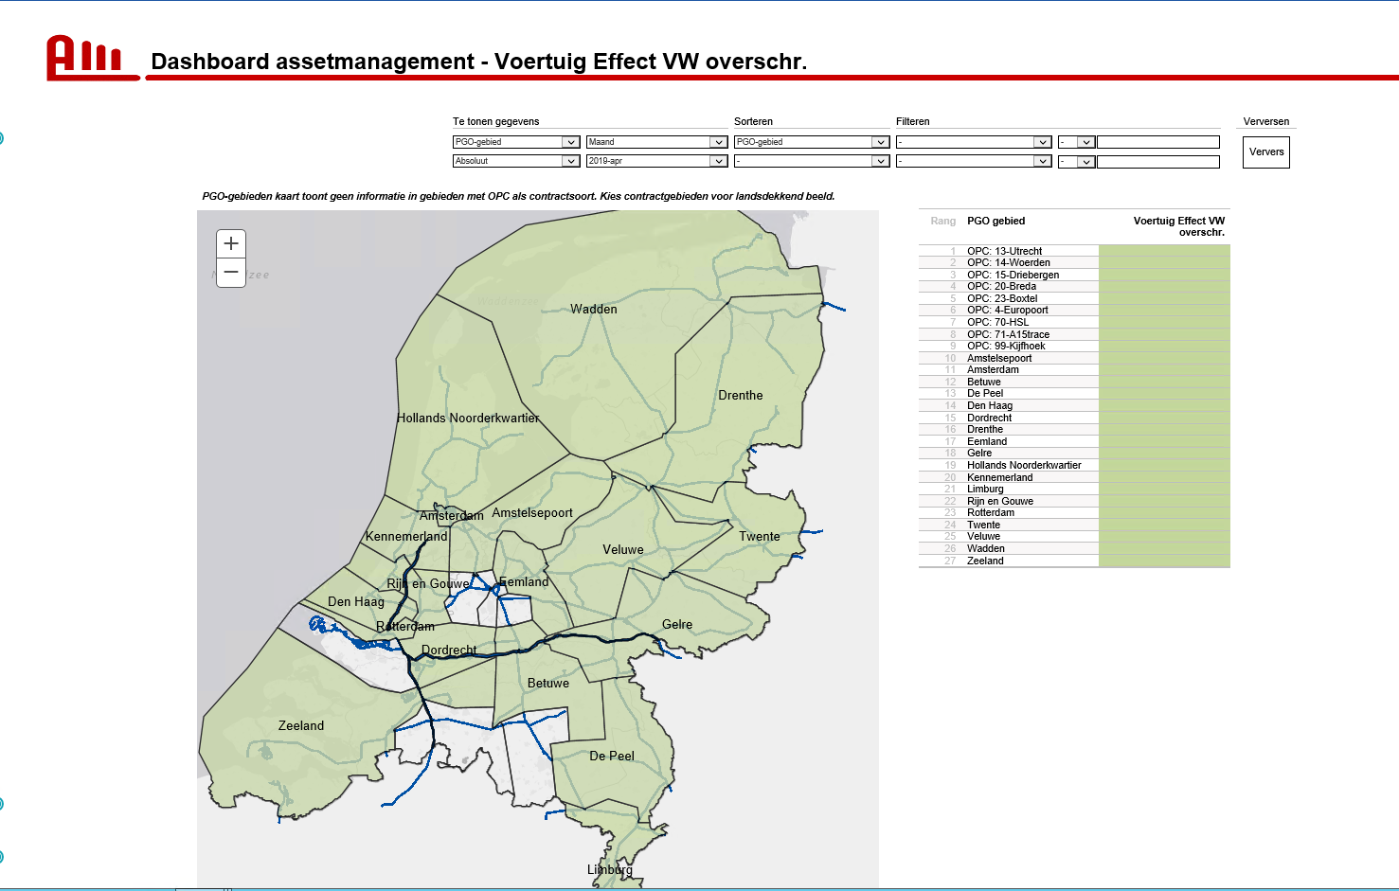
Cognos report in Cognos Connection (Run HTML)
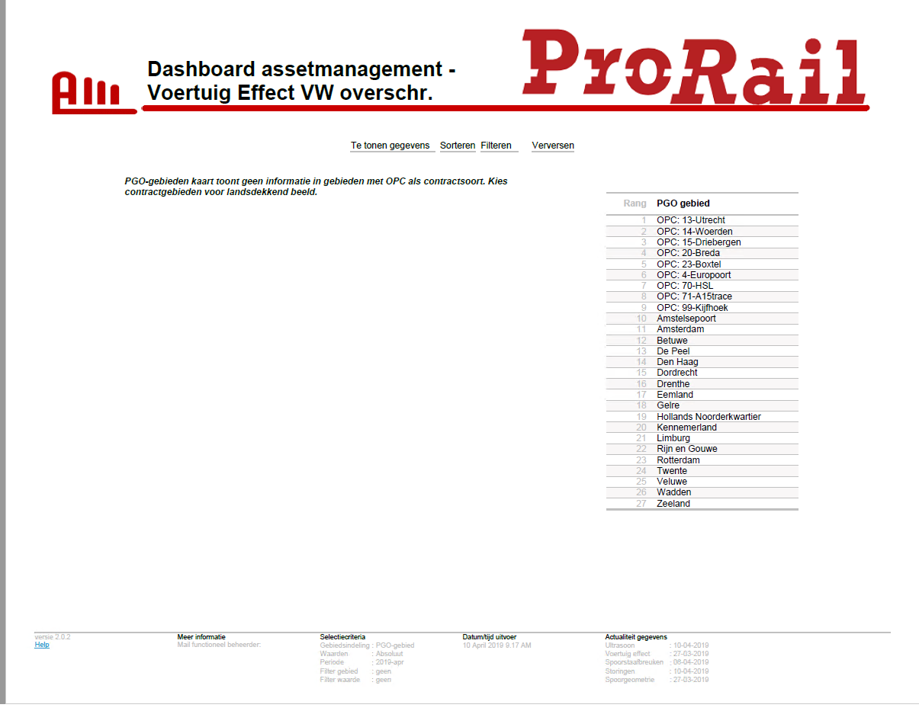
Cognos report in Cognos Connection (Run PDF)

