RFE Title: New UI – Redirect to Single Edit of Collaboration Area if item is already checked out
RFE Description:
In New UI, if the item is already checked out, clicking the button “Checkout” displays below error message:
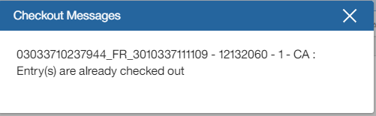

It should be extended such that instead of displaying the error message, UI just opens the item in Single Edit of Collaboration Area.

