Error : Malicious attack has been detected. Your session has been terminated

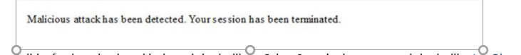

I did a further check and it doesn’t looks like a Cyber Security issue to me, it looks like Joe Bloggs tried to upload a text with special characters like ';" etc which looks like cross-site scripting (XSS)

Can you please check what is being uploaded on the fields. This seems to be a standard error on Helios (IBM Open pages) where someone may be trying to upload text that looks like XSS.

