Assuming these are your SQLCODE counts

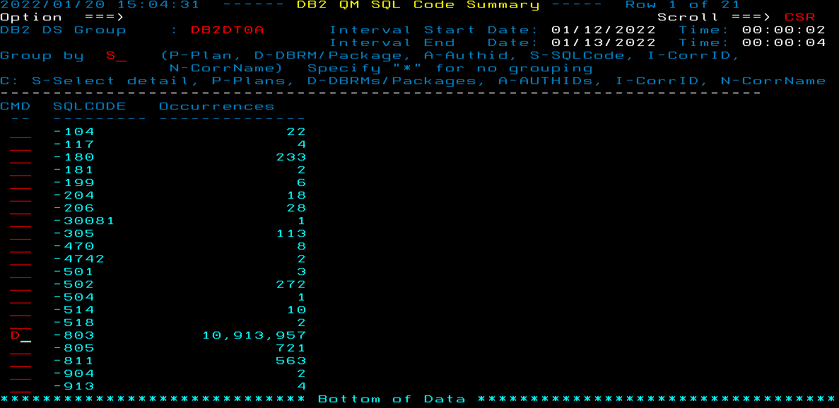

When you ask for more breakdown of a particular SQLCODE, the breakdown should show everything that made up the previous count even if there are no details recorded.

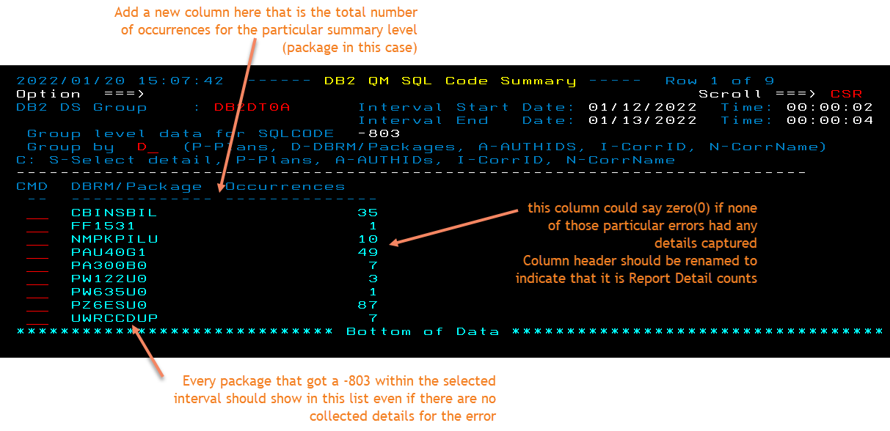

The new column should total up to the same number as what is shown when you group by SQLCODE.

The new column should be available and work the same way for each of the additional breakdown options (P-Plan, D-DBRM/Package, A-AUTHIDs, etc, etc)