In CP4D 4.0.7 it was possible to define a custom environment via GUI:
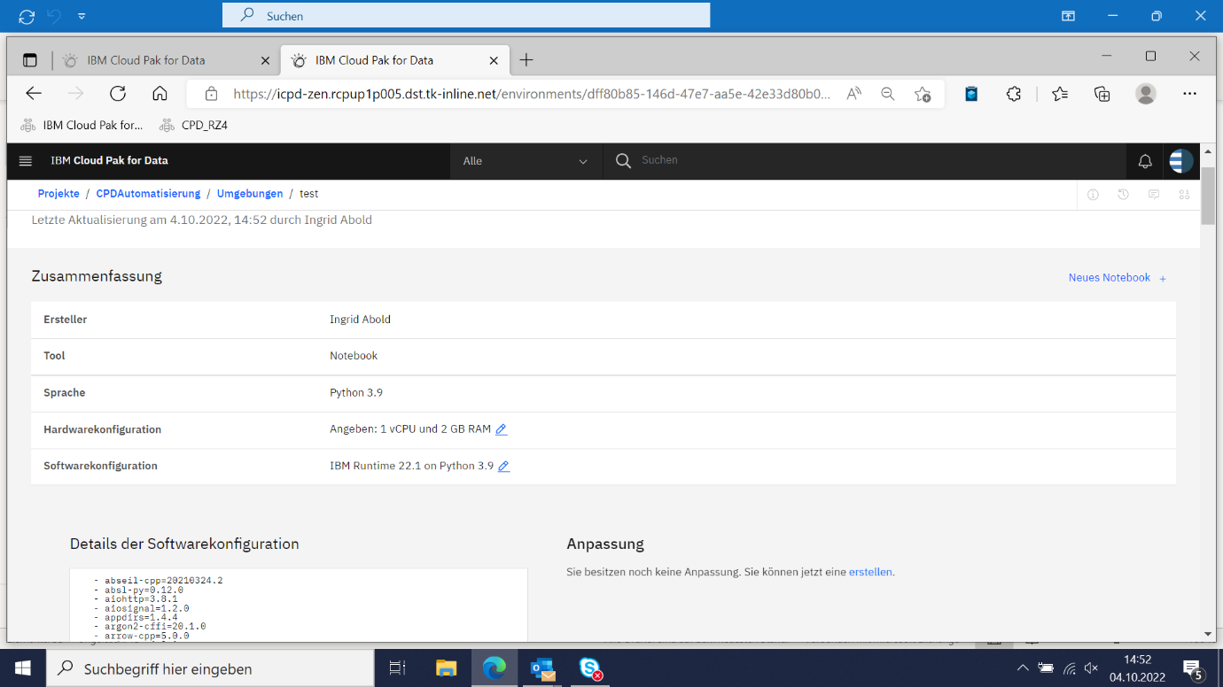

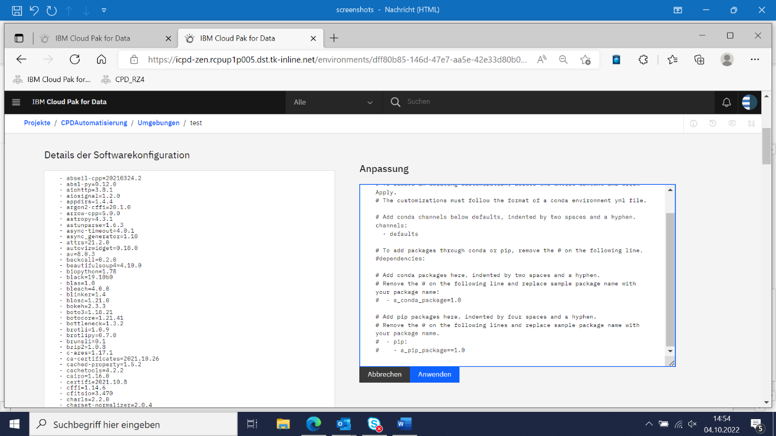

- Gone in CP4D 4.5.2

For no Git and old Git integrated projects we additionally can promote custom environments to a deployment space (in CPD 4.0.7 + 4.5.2)
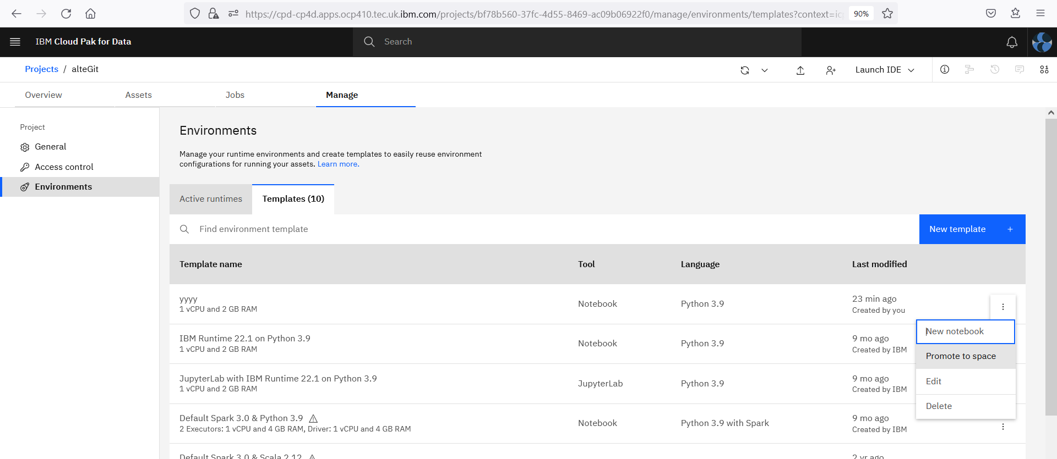

We need the GUI from 4.0.7 back together with the possibility to promote a custom environment to a deployment space also for the new Git integration.
The promoted custom environment should also be accessible for all artefacts in deployment.
(example: model batch deployed)
Additional installed packages should persist.

