Enable the copy - paste functions from local PC to VNC graphical sessions opened within the Application Center (PAC) portal.

Copy and paste functions from local PC to VNC sessions are crucial to work in a smooth way. These functionalities are not available in the PAC portal product.

Copy /paste "echo hello" from notepad opened locally on the PC to VNC terminal in PAC window doesn't work.
The same happens if you try to copy a text from the VNC session opened within the LSF PAC and paste it locally into a notepad.
By connecting via VNC Viewer directly from the local PC to the VNC server, on the "Xvnc :2" display, it is possible to copy and paste the text.

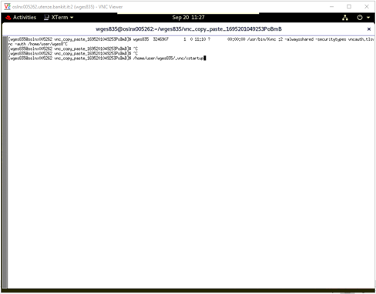

While, if you try the same actions from the VNC graphical session opened by LSF PAC on the same server on the "Xvnc:2" display, the copy & paste from/to local PC doesn’t work.

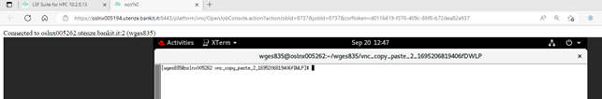

The requirement is to improve the Application Center in order to support copy & paste functions in both ways.
Copy paste seems to work only within noVNC sessions, for example copying a text and pasting it using the middle mouse button or shift+ins. (This functionality is reported on the home page of the noVNC project on github https://github.com/novnc/noVNC#Features)

